
GOVERNMENT OF PAKISTAN
DISTRICT HEALTH OFFICE, ISLAMABAD
MINISTRY OF NATIONAL HEALTH SERVICES, REGULATIONS & COORDINATION
*********
F. No. 10(173)/24-25-DHO/ICT 26-02-2026

THE DIRECTOR ADVERTISEMENT,
Press Information Department
Government of Pakistan,
Near Zero Point, G-7/1,
Islamabad.

SUBJECT: PUBLICATION OF TENDER NOTICE PROCUREMENT OF MACHINERY & EQUIPMENT(GOODS).

Please find enclosed a Tender Notice for publication in the following newspapers positively.

News Paper

Urdu newspaper to be circulated nationwide across Pakistan

English newspaper to be circulated nationwide across Pakistan

2. Bill along with a copy of the News Paper carrying the advertisement may be sent to this office for payment on Government prescribed rates.

(DR. FAWAD KHALID KHAN)
Chairman Procurement Committee
District Health Office, Islamabad
Copy to:

- Director (I.T), Public Procurement Regulatory Authority (PPRA), FBC Building, G-5/2, Islamabad – for upload of the advertisement on the PPRA website.
- Deputy Director (I.T), Ministry of National Health Services, Regulations & Coordination – with a request to upload the invitation on the Ministry’s website.
- Mr. Ahsan, IT Section, District Health Office – with a request to upload the invitation on the DHO office website.
- Office Copy.

Section: I
TENDER NOTICE
INVITATION TO BIDS

PROCUREMENT OF GOODS

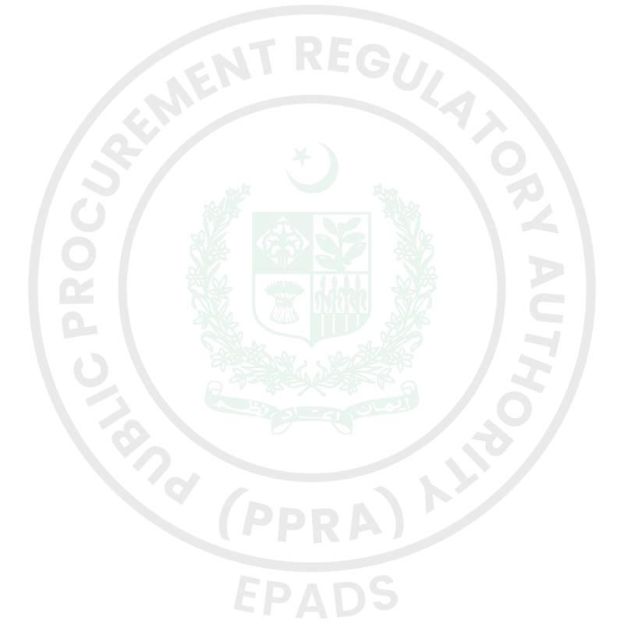
- The District Health Office (Ministry of National Health Services Regulations and Coordination (NHSR & C)) has reserved Funds for the procurement planned for FY 2025-26. The District Health Office (Ministry of National Health Services Regulations and Coordination (NHSR & C)) intends to apply part of the proceeds of this Fund to cover eligible payments under the contract for the "Procurement of Machinery & Equipment".
- The District Health Office (Ministry of National Health Services Regulations and Coordination (NHSR & C)) invites E-bids from eligible Bidders for procurement of goods described in the bidding documents on EPADS v2.0.
- Single Stage-Two Envelope will be used by adopting Least Cost Based Selection (LCBS)Technique for the subject procurement, in line with the Public Procurement Rules, 2004 and any Regulations, Regulatory Guides, Procurement Guidelines or Instructions issued by the Authority from time to time.
- All Bids must be accompanied by a Bid Security amounting described in Bid Security Section in Bidding Document in the form of Call at Deposit. Where Bid Security is not required by the Procuring Agency, Bidders are required to furnish Bid Security Declaration as specified in Bidding Document.
- E-Bidding documents, containing detailed terms & conditions, specifications and requirements etc. are available on e-Pak Acquisition and Disposal System (EPADS) at https://vendors.epads.gov.pk/.
- Bidder(s) are required to get themselves registered on EPADS v2.0 on or before Monday, March 16, 2026 10:00 AM. E-bids will be opened using EPADS v2.0on the same day at Monday, March 16, 2026 10:30 AM. Manual submission of Bids shall not be entertained. Those vendors who have not yet registered on the new version of EPADS v2.0, may register themselves on https://vendors.epads.gov.pk/. A tutorial to explain the registration process is available at https://www.youtube.com/watch?v=MNW6T38v7tc

In terms of Rules 48 of Public Procurement Rules, 2004 Grievance Redressal Committee (GRC) is notified for the subject procurement and notification copy is available on the procuring agency’s website and on Authority’s website at ( www.ppra.org.pk).
- The Bidders may seek clarifications through EPADS v2.0 Clarification Date Monday, March 2, 2026 Pre-Bid Meeting: Tuesday, March 3, 2026 10:00 AM Venue: Committee Room of the District Health Office, Islamabad,
- District Health Office (Ministry of National Health Services Regulations and Coordination (NHSR & C)), Incharge Procurement Sector G-9 Markaz., Islamabad Capital Territory

DR. SYEDA RASHIDA BATOOL
DISTRICT HEALTH OFFICER (DHO)

